Exercises - Lab02

Examine the robot-map shown. Let Athlete maria = new Athlete();

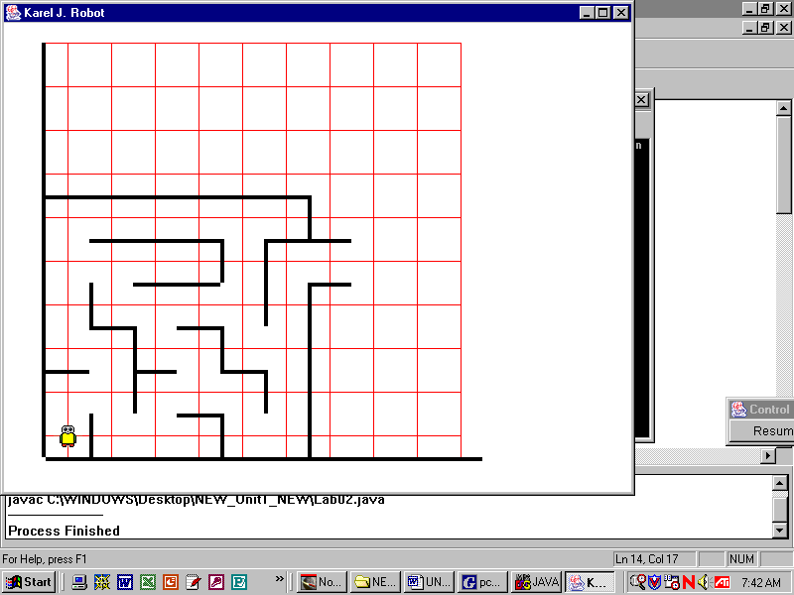

**1) Write the commands to put one beeper at the indicated location.**maria.move();  
maria.turnRight();  
maria.move();  
maria.turnRight();  
maria.move();  
maria.turnLeft();  
maria.move();  
maria.turnLeft();  
maria.move();  
maria.putBeeper();

1. **Use a different path from your answer from Question #1. Write the commands to put one beeper at the indicated location**

maria.move();

maria.turnRight();

maria.move();

maria.turnLeft();

maria.move();

maria.turnLeft();

maria.move();  
maria.turnRight();  
maria.move();  
maria.move();  
maria.turnRight();  
maria.move();  
maria.turnRight();  
maria.move();  
maria.turnLeft();  
maria.move();  
maria.turnRight();  
maria.move();  
maria.turnLeft();  
maria.move();  
maria.turnRight();  
maria.move();  
maria.turnRight();  
maria.move();  
maria.putBeeper();

**3) Lab01 used three classes, Lab01, Display, and Robot. Label the boxes (it’s called a UML diagram), showing the class relationships. Label the arrows with “hasa.”**

Robot

Display

Lab01

hasa

hasa

4) Lab02 involved four classes, Lab02, Display, Robot, and Athlete. Label the boxes in the UML diagram, showing the class relationships. Label the arrows with “isa” or “hasa.”

Robot

isa

hasa

Display

hasa

Lab02

Athlete